**Prediction of optical waveguide parameters using CNN - Proposal**

Xuan Chen

Student # 82286956

# Introduction and Motivation

Electromagnetic waves can travel along waveguides using different mode, which are TE (Transversal Electric) and TM (Transversal magnetic). Generally, we use dimensions (width and height) of waveguide to judge its mode. It is common to think about reversing it: using pattern modes to predict the dimensions of waveguide, so that it can be used in some precision instruments for detecting. But physical fields represent quantities that vary in space and/or time axes. It is very difficult for us to calculate the dimensions of a waveguide manually. According to the convolutional property of CNN (Convolution Neural Network), deep learning model is created by assuming the field values as inputs, and the geometrical dimensions of the waveguide as outputs. A model can be created by using the inputs and outputs to predict the parameters (width and height) of optical waveguide. The proposal will introduce the related literature, motivation of my task, model architecture, and challenges I might meet in the process.

# Related Literature

Generally, there are two topics in optics, one is “optics for AI” and the other is “AI for optics”. The second theme is more related to my current work. In “Deep Learning Book”, it illustrates what convolution is, and explains the motivation behind using convolution in a neural network. It introduces basic knowledge of CNN, such as how convolution can be applied to many kinds of data with different numbers of dimensions, which constructs a foundation of my current model.

In paper “Leveraging AI in Photonics and Beyond”, Gandhi Alagappan and other researchers illustrates In a celestial manner, the behavior of electromagnetic waves corresponding to this entire spectrum can be succinctly described by the golden set of Maxwell equations. The entire cycle of design, modeling, and simulation carried by soft computing algorithms will accelerate execution speeds by two to three orders of magnitude. They analyzed the number of the publication with topics including AI and photonics from web of science is searched by conditions: AI (topic) or deep learning (topic) or machine learning topic) and photonics

(topic) from 1996 to 2021.

In another paper of Gandhi Alagappan called “Prediction of electromagnetic field patterns of optical waveguide using neural network”, the authors used RNN and FNN architectures to predict mode pattern for an optical waveguide with width and height. The paper shows how field patterns can be predicted by employing artificial neural networks. The FNN and RNN models are trained using a set of simulated datasets, obtained by solving the Maxwell’s equation.

From these papers, I got a connection between electromagnetic field patterns and neural networks.

# Research Design

From the paper “Prediction of electromagnetic field patterns of optical waveguide”, assuming the field values as outputs, and the geometrical dimensions of the waveguide as inputs. The correlation between the field values in the adjacent pixels is established by mean of feedback using a recurrent neural network. The trained deep learning model enables field pattern prediction for the entire (and usual) parameter space for applications in the field of photonics. The results are electric field distribution (Figure 1).

Figure 1 (a) Squared absolute value of the electric field (the first TE mode) as a function of x and y [(w, h, nc) = (0.6 micron, 0.45 micron, 2.2)]. (b) One-quarter of the image in a is discretized into N tiny pixels. The respective field in each pixel is denoted as Fi, where the subscript i varies from 1 to N

I chose Convolutional Neural Network to predict electromagnetic field patterns. We can recognize the pattern from a view of smaller area, thus we have receptive field. With the combination of receptive field and parameter sharing, we call it convolutional layer. Fully connected layer can be used in many situations, but it might not do that well in specific problems. Like CNN, it has a larger model bias, it might not a bad thing. Because CNN is specialized in dealing with pictures because of it contains some characteristics of figures. That’s what we say each performs his own function. Therefore, I will make the electric field patterns figures as my input (Figure 2 the original dataset), let width and height of waveguide as my output.

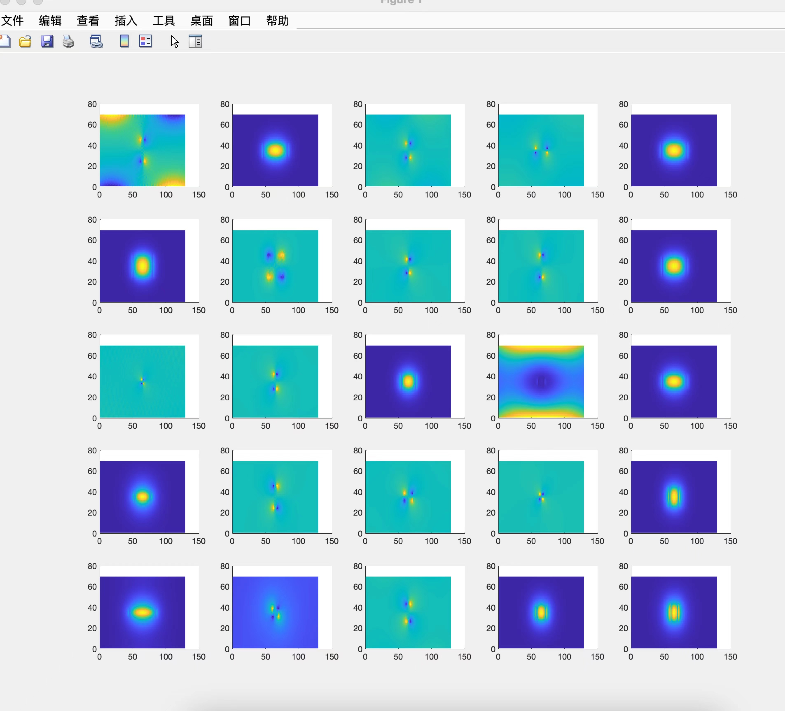

Figure 2 Input – Electric field patterns

The input layer reads in a regularized (uniformly sized) image. Each neuron in each layer takes as input a small set of local nearest neighbors from the previous layer, i.e. the local perceptual field and weights are shared, and the neuron extracts some basic visual features, such as edges, corner points, etc., which are later used by higher level neurons. Convolutional neural networks obtain feature maps by convolutional operations, and at each location, units from different feature maps get their own different types of features. A convolutional layer usually contains multiple feature maps with different weight vectors, allowing a richer feature set of the image to be retained. The convolution layer is followed by a pooling layer for down sampling, which reduces the resolution of the image and the number of parameters on the one hand and obtains robustness for translation and deformation on the other. The alternating distribution of convolution and pooling layers results in a bipyramidal structure with a progressively larger number of feature maps and a progressively lower resolution.

## Overview of Model

A CNN is essentially an input-to-output mapping that learns a large numbers of mapping relationships between inputs and outputs without requiring any precise mathematical expressions between inputs and outputs; as long as the convolutional network is trained with known patterns, the network has the ability to map between input-output pairs.

#### Parameter initialization:

Before starting training, all the weights should be initialized with several different random numbers. The "small random numbers" are used to ensure that the network does not become saturated with too many weights, which could lead to training failure; the "different" numbers are used to ensure that the network can learn properly. In fact, if the same number is used to initialize the weight matrix, the network will not be able to learn.

#### The training process consists of two stages:

(1) Phase 1: Forward propagation phase. Take a sample from the sample set and input it to the network.

Calculate the corresponding actual output; in this phase information is transmitted from the input layer to the output layer through a step-by-step transformation, a process that is also performed by the network when it performs normally after completing training.

(2) Phase 2: Backward propagation phase. The difference between the actual output and the corresponding ideal output is calculated; the weight matrix is adjusted according to the method of minimizing the error.

#### CONV Layer

A data input, assumed to be a graph of RGB. In a neural network, the input is a vector, but in a convolutional neural network, the input is a multi-channel image.

#### Structure Design

Already built a basic model, still in adjustment.

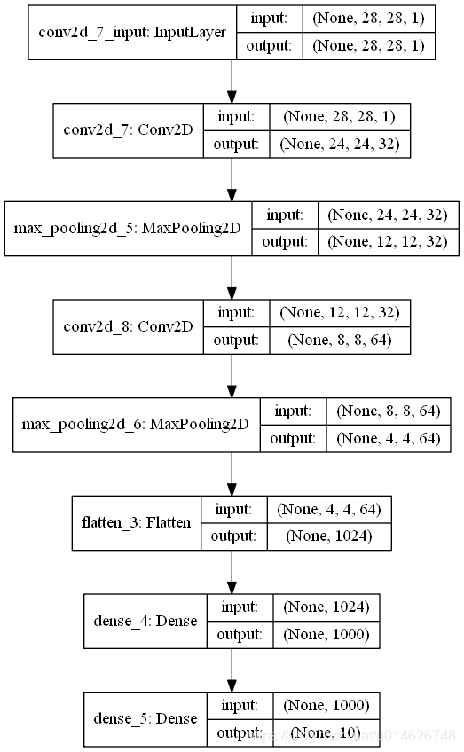

Figure 3 Model Stucture

## Evaluation

Using mean squared error (MSE) to evaluate the exact result and the predicted one. MSE measures the amount of error in statistical models. It assesses the average squared difference between the observed and predicted values. When a model has no error, the MSE equals zero. As model error increases, its value increases.

In regression, the mean squared error represents the average squared residual. As the data points fall closer to the regression line, the model has less error, decreasing the MSE. A model with less error produces more precise predictions.

# Challenges

## Pre-process the dataset. The original dataset is a rectangle figure with a size of 129*69, which needs to be pre-processed. (completed)

## Adjust model, compare which kind of model is most suitable for this data. (in process)

## Deal with muliple inputs datasets. (not start)

# Project Schedule

Phase 1: 20 Oct – 3 Nov: Search information and document of the project, prepare the proposal and the slides of the project. Pre-processing datasets.

Phase 2: 5 Nov – 25 Nov: Build the model and adjust it.

Phase 3: 25 Nov – 4 Dec: Finish the paper and final presentation.

# Reference

### Chapter 9, 9.1-9.3 of Deep Learning Book

### Procedia Computer Science 132(2018)377-384 “An Analysis Of Convolutional Neural Networks For Image Classification”.

### Szegedy, C., Liu, W., Jia, Y., Sermanet, P., Reed, S., Anguelov, D.,&_Rabinovich, A.(2015) “Going deeper with convolutions.” in Proceedings of the IEEE conference on computer vision and pattern recognition (pp. 1-9).

### Alagappan, G.; Ong, J.R.;Yang, Z.; Ang, T.Y.L.; Zhao,W.; Jiang,Y.; Zhang,W.; Png, C.E. Leveraging AI in Photonics and Beyond. Photonics 2022, 9, 75. https://doi.org/10.3390/photonics9020075

### C. M. Chew and W. H. Weedon, “A 3d perfectly matched medium from modified Maxwell’s equations with stretched coordinates”, Microwave and Optical Tech. Lett., vol. 7, No. 13, pp. 599-604, 1994

### <https://pyimagesearch.com/2019/02/04/keras-multiple-inputs-and-mixed-data/>

### AI4D Proposal: Deep learning optimization of frequency microcomb